From:
SHANER SPORTSMEN’S CLUB, INC. 146 STEWART LANE
IRWIN, PA 15642
Officers Regular Montly Meeting Meeting Ticket

Sep 7, 2023 | Sep 11, 2023 | Sep 12, 2023
Sep 28, 2023 | Oct 2, 2023 | Oct 3, 2023
Nov 2, 2023 | Nov 6, 2023 | Nov 7, 2023
Nov 30, 2023 | Dec 4, 2023 | Dec 5, 2023
Jan 4, 2024 | Jan 8, 2024 | Jan 9, 2024
Feb 1, 2024 | Feb 5, 2024 | Feb 6, 2024
Feb 29, 2024 | Mar 4, 2024 | Mar 5, 2024
Mar 28, 2024 | Apr 1, 2024 | Apr 2, 2024
May 2, 2024 | May 6, 2024 | May 7, 2024
May 30, 2024 | Jun 3, 2024 | Jun 4, 2024
Jun 27, 2024 | Jul 1, 2024 | Jul 2, 2024
Aug 1, 2024 | Aug 5, 2024 | Aug 6, 2024
Sep 5, 2024 | Sep 9, 2024 | Sep 10, 2024

2023/2024 Newsletter
SHANER SPORTSMENS CLUB, INC

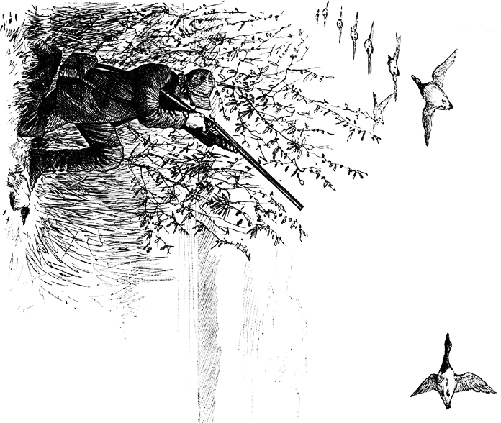

SHANER SPORTSMEN’S CLUB 2023/2024 NEWSLETTER
Shaner Sportsmen’s Club Web Site:

www.shanerSC.org
Shaner Sportsmen’s Cell Phone and Message Machine:

724-446-1313
We urge all members who have access to a computer to sign up on the Club’s e-mail list. If you are not on the list, see a club officer to get added.
REMINDER
The Club’s fiscal year is September 1 to August 31.

CURRENT DUES:
Individual: (18-62): $65.00 and includes children under 18 years old.
Couple: (husband & wife): $95.00 & includes children < 18 year old.
Senior: (63+): $45.00 and includes grandchildren under 18 year old.
Life Members: 65 and Older with 15 consecutive years in club): Free. Life members are required to pick up a current membership card/pin each year and purchase the three (3) fall fundraising tickets.
New Members: are above rate plus $100.00 initiation fee and membership in the NRA. If you are a member see the Treasurer to give your NRA Membership ID#. If you are not in the NRA they offer, through the Club, $10 Associates Membership - see the Treasurer to join. Members joining after May 2014 must maintain an active NRA membership – either through the club or directly with the NRA.
Active Members of the Armed Forces & Students living away from home: Free.

MAJOR IMPROVEMENTS
- Food plots have been planted for the benefit of all our wildlife, corn, pumpkins but deer have decimated almost all of it. Also turnips, Biologic and winter wheat will be planted.
- New metal roofs have been installed on club house, old garage, 50 yd and 100 yd pavilion thanks to partial NRA grant, June 2022.
- Survey of all the Shaner properties, including the far back field, was completed in April this year. A framed map is on the wall between the bathrooms, courtesy of Mike White.
- Sewickley Township is in the process of creating a new road to go around the section that is collapsing. This will be a land swap, we get the old road as part of Shaner and they will maintain the new road. We will keep you informed of construction dates.
- Please keep dogs on leash during May/June/July to protect the flocks of turkey poults and young deer.
- Creek Archery Targets - Please do not use broadheads on the field point targets because it shortens their life.
- All members are required to have their club pin visible when hunting on club property. NO EXCEPTIONS.
- Only active members can hunt on club property. NO EXCEPTIONS.
- The area of the club towards Mark Lord’s place is declared a Safety Zone to protect our neighbors from stray gunfire. Members are reminded that hunting is strictly prohibited in the areas posted as Safety Zones.
- The Milicki property is OFF LIMITS.
- Mrs. DeClaudio/Consol property is now a PGC co-op.
  - DON’T CROSS FENCES ONTO PRIVATE PROPERTY

Please Support Our Sponsors:
*NRA *Rocky Mountain Elk Foundation
*Peters Creek NWTF *National Wild Turkey Federation
*Fox's Pizza-West Newton *Green’s Funeral Home
*Basic Carbide *Allegheny Mountain Knife Collectors Assn
*Espey's Meat Market *Creek Archery Shop
*The Embroidery People *Tandy Leather
*Salvio Heating & Air *MRK Construction
*Allegheny Petroleum

HUNTER TRAPPER EDUCATION (HTE)
Class sizes are limited, please register on www.pcg.state.pa.us website
  - Hunter Safety Course is FREE - lunch included
  - Sunday, September 24, 2023 - 8 a.m. to 4:00 p.m
  - Second course tentatively scheduled for March 2024..

PHEASANT STOCKING SCHEDULE

Bird stocking October 21, 2023 for Youth Pheasant Hunt Additional stocking in November, 2023
No dogs before noon either day.
TRAP PRACTICE
Stop by on any Friday night at the club, where we practice for the league or hunting. Practices are open to the public, members and non- members alike, from 5:30 until approximately 8:30.
Member cost is still $3.50/25 birds, non-members $4.00/25 birds.
TREE STANDS
Tree stands (limit 2) must be tagged prior to installation – obtain tags from an officer; member must also sign waiver. Tags must be visible from the ground.
Stands can be put up starting August 19th; must be removed by March 31st or they are forfeit.
YOUTH TRAP LEAGUE
Fall League Shooting times – Friday night practices at Shaner starting @ 6 pm, open to all students whether shooting league or not.
Wednesday night practices @ Herminie (6 – 8 pm), open to all students whether shooting league or not.
Registration 8/1/23 thru 9/11/23
League scoring starts Sunday, September 17 (reserve week), 12:00 noon and runs for 6 weeks until Sunday, October 29th.
Final makeup will be on Friday, October 27th @ Shaner.
Snacks and drinks are available.
See Stephanie McDonough, 412/551-2326 for further details.
Spring League details will be provided at a later date – handouts will be available at Shaner Sportsmen Club, Herminie #2 Game Association or thru Stephanie.

APPLICATION INFORMATION
New Applications are not processed until the applicant attends both an officers meeting for an interview and the following vote-in meeting. Get dates when application is turned in. If unable to attend those meetings please contact an officer to make arrangements.
***Membership is closed from October 1st, through December 31st ̴ Applications are accepted but not processed until January.***

DUES
Dues are collected starting at the September meeting and are payable until end of October. After that, a $20.00 late charge will be added. Dues can also be paid on Friday nights at the club starting at 6:00 pm. If dues are not paid by December 31st, you will be dropped from the membership list. Contact a club officer if there are any questions or problems. We also accept dues by mail.

FUND RAISER
Beginning September 1st, 2013 each member will be responsible for three (3) Fall Fund Raiser tickets each year. A penalty of $40.00 will be assessed to each member who fails to sell or buy at least three (3) fund raiser tickets. (Note: As of Sept 2015, the Spring Fund Raiser has been eliminated). Tickets dates are Dec 5, 6, 7, 8 & 9, 2023.

RANGE RULES
*·Current membership must be showing or produced upon request
- Open Mon-Fri 9 am to dusk, Sunday 10 am to dusk
- Paper targets only on belting * Shotguns use pattern board
- Do not leave live rounds * Pick up spent cartridges/trash/targets
·*No crossfire * Above all, be safe & responsible
Thanks to Brian May for new sign!

All ranges will be closed on the following dates:
Saturday, October 21, 2023: Youth Pheasant Hunt - 8:00 A.M.- 4:30 P.M.

Saturday, November 25, 2023: 1st Day of Deer Rifle Season
.ALL RANGES ARE CLOSED WHEN THE CLUB IS RENTED, NO EXCEPTIONS.
I would like to thank all the other officers for the hours they put in and all the members who stepped up to help. Thank you all for your hard work and dedication to Shaner Sportsmen’s Club. Out of respect, leave their land the way you found it.
Thank You, The Officers

WORK HOUR REQUIREMENTS

Eight (8) hour work requirements as follows:

Meeting attendance 1 hour
Every 10 tickets sold 2 hours Working a club shoot or activity 4 hours
*Mandatory Club Maintenance 2 hours
Work hour requirements are applied at the membership level, not at the individual level.

*All members except lifetime, honorary, and landowners must perform two (2) mandatory club maintenance hours during a scheduled work detail or other form of club maintenance. The remaining six (6) hours can be credited by meeting attendance, ticket sales, or helping at a club function.
*Up to six (6) non-mandatory hours may be purchased at
$20.00 per hour for members unable to attend meetings or sell tickets. The Vice-President, Secretary or a Director will verify the mandatory club maintenance requirement.
*Membership will be denied any individual that fails to receive credit for the eight (8) hours per year including the two
maintenance hours from August 1st, to July 31st, of the following year.

*Hunt safely, respect our landowners, respect the land you hunt*

UPCOMING EVENTS FOR 2023/2024

Club Family Picnic/Wild Game Dinner:
Free to club members and their families. Please bring a covered dish. Games/prizes for kids. For adults 50/50 raffle and gun raffle. Next picnic date to be announced.
Youth Trap League - Fall 2022: Sunday, September 17, 2023 thru Sunday, October 29th – shooting on Friday nights starting @ 6 pm. See Stephanie McDonough, 412/551-2326, to register.
Youth Pheasant Hunt: Saturday, October 21, 2023, starting 8 am. Junior hunters only, ages 9 to 16. (relatives of Club Members only). Refreshments will be served at the club house. No dogs until after noon. Adult members can hunt after Jr. hunters are done.
Pheasant Opener Breakfast: Saturday, October 21, 2023 - starting 6 am- 8 am. Come to eat & watch the hunt. Hunt to begin promptly at 8 am.
Running Deer: (weather permitting) Sunday, November 5, 2023 -
starting 10 am. Trap range will be opened upon request. Refreshments will be available. Rifles, slug guns or bows welcome.
Lucky BB/Egg/Turkey Shoot: (weather permitting) Dates to be determined. Refreshments will be available.
Youth Trap League - Spring 2023: Dates to be announced later. Flyers will be available when season is set. See Stephanie McDonough, 412/551-2326, to register.
Youth Field Day: Saturday, August 10th, 2024 - 9:00 a.m. to 3:00 p.m. Open to the public, Class size is limited, register on-line at www.pcg.state.pa.us. under -“Attend a Field Day”: FREE, ages 8 to 16. Attendees will learn to shoot archery, muzzleloaders, .22 rifles and shotguns on the trap range. For information call
724-872-8431 or 724/446-1313
Annual Property Posting: Sunday, September 10, 2023. Groups will post the recently surveyed property lines with purple paint.

